Task1

1_ selecting data sets:

I use 2 data sets for my research one as a primary and the second is secondary and I choose them from [kaggel](https://www.kaggle.com/datasets?search=cyber+security&page=5):

A_ data preview: ([secondary datasets](../Datasets/ai_ml_cybersecurity_dataset.csv)).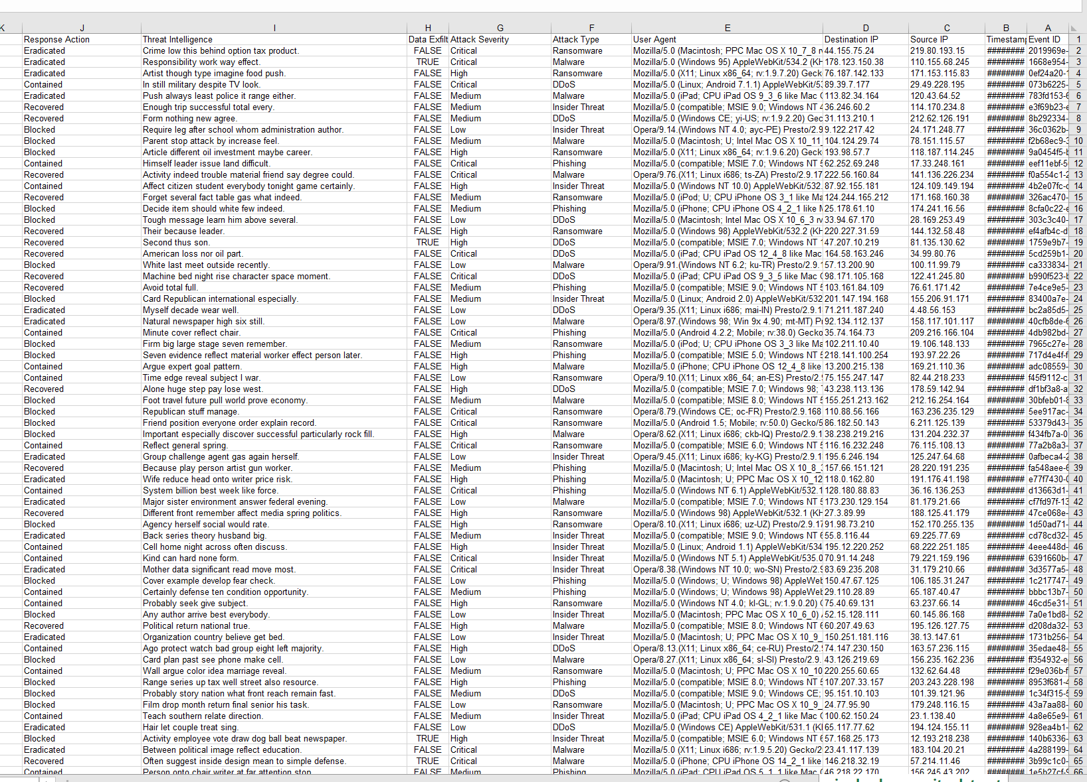

Name: ai_ml_cybersecurity_dataset

B_ data preview: (primary datasets).

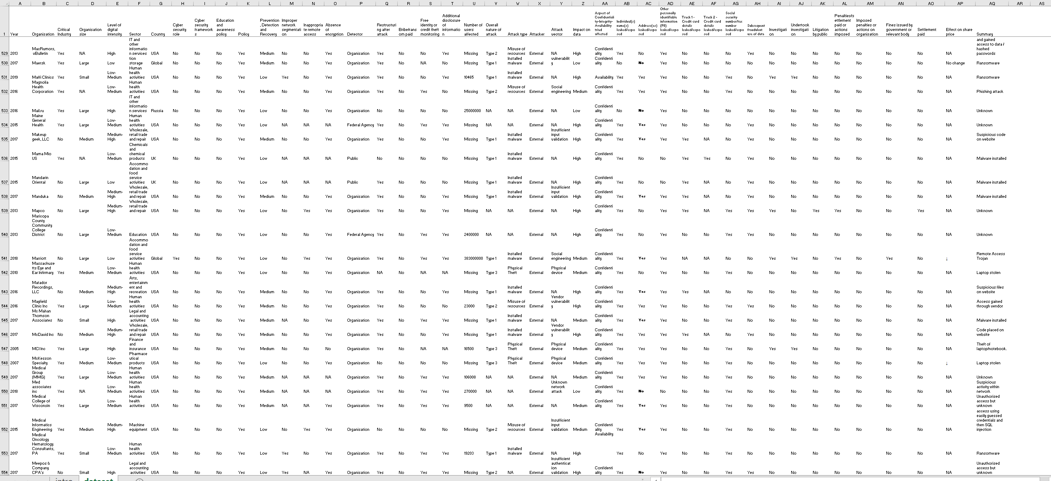

Name: Dataset-cyberattacks.

The idea or the problem of the research:

My main question is "what is the main reason of the data breaches". And I choose the primary dataset to extract the answer of my question because of the plenty information of it.